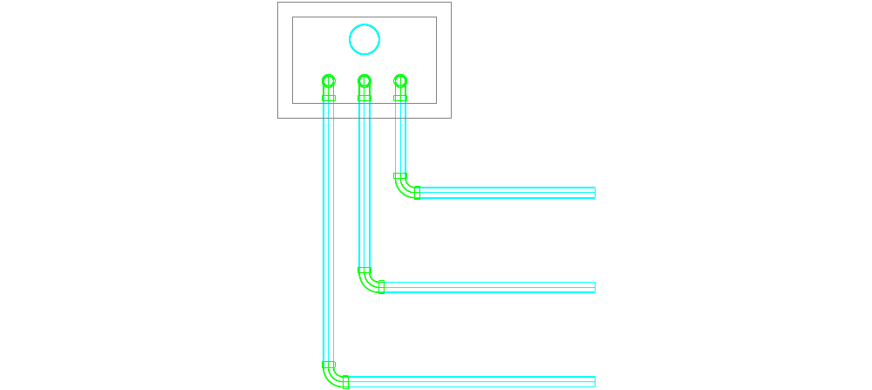
Δ x
offset
Δ y
disp
width.sed

- Δ x is the distance in the x direction from a top view from the outlet of the sed tanks (or the origin of these pipes) to the outside wall of the leveling tank
- Δ y is the distance in the y direction from a top view from the outlet of the sed tanks (or the origin of these pipes) to the outside wall of the leveling tank
- Δ z is the distance in the z direction from a top view from the outlet of the sed tanks (or the origin of these pipes) to the bottom wall of the platform
- offset is the tank x dimension was divided by the number of tanks to evenly space the pipes
- ElbowRadius is the radius of curvature of the elbow
- disp is the displacement of the center of the pipes coming up into the leveling tanks from the inside wall of the tank
- width.sed is the distance between the outlets of the sed tanks or the width of the sed tanks from the center line of the wall on either side of a tank

* Note that the floor of the leveling tank is at the same elevation as the top of the platform

L.pipe1
L.pipe2
L.pipe3

L.pipe4
L.pipe5

L.pipe6

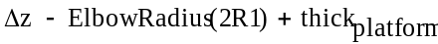
L.pipe7

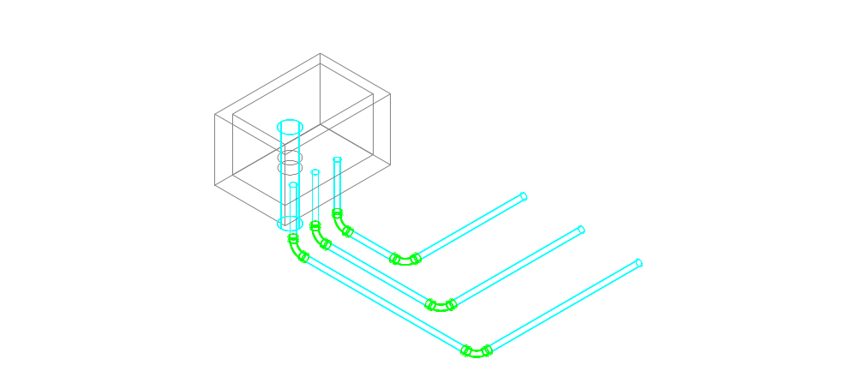
Pipe 1
Pipe 2
Pipe 3
Pipe 5
Pipe 4
Pipe 6
Pipes 7

